# Debugging Exercises

Name: Jack Norrie  
Campus: AIE Programming @ Wentworth Campus

## Exercise 1: Run the Debugger

Run the Debugger Upload a screenshot of Visual Studio running in debug mode.  
Insert Screenshot

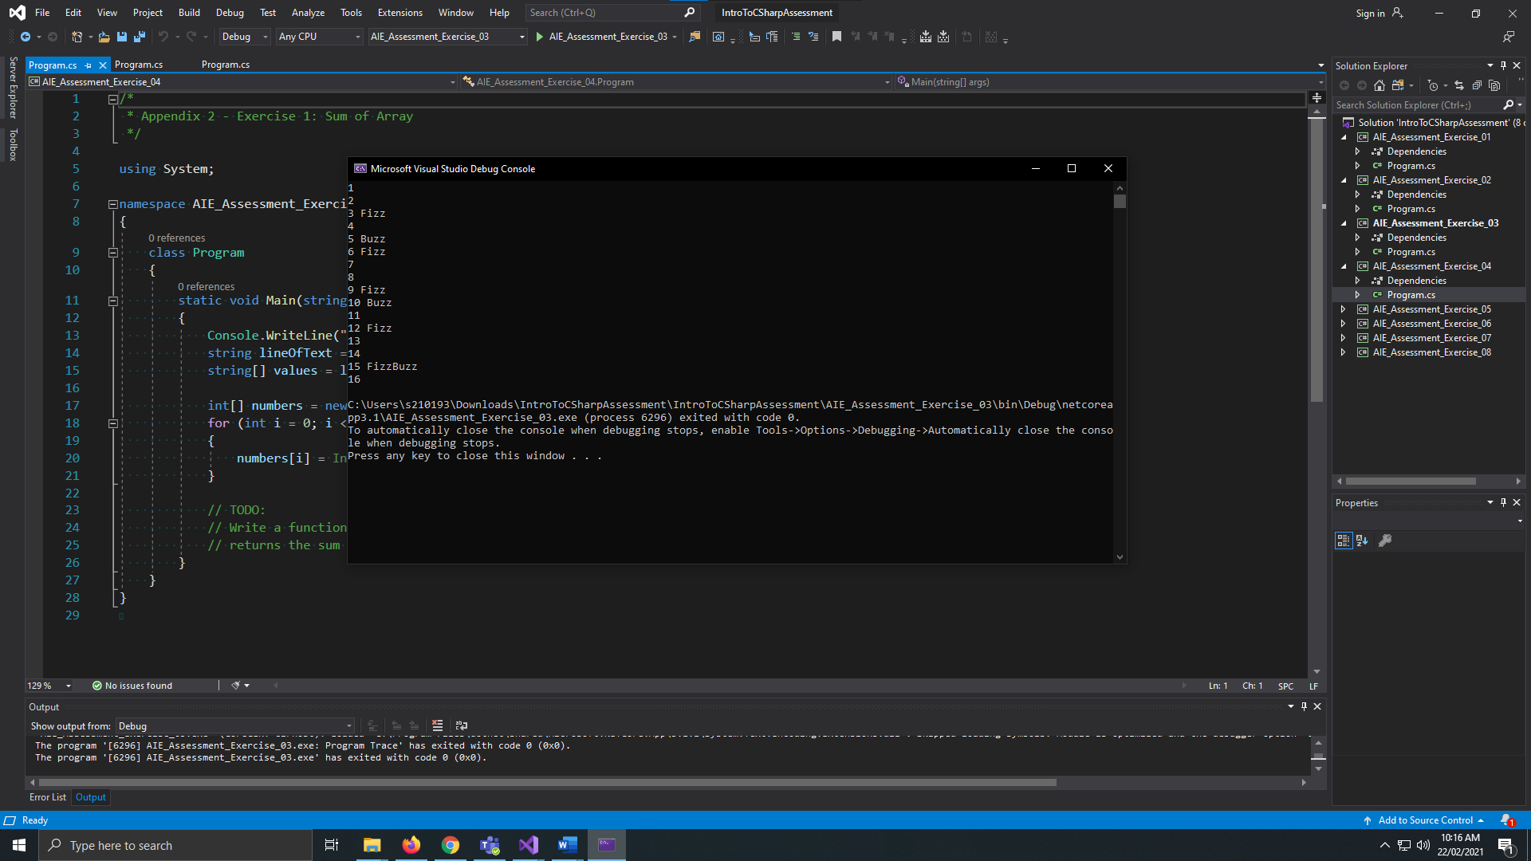

## Exercise 2: Compiler Errors

Upload a screenshot of 3 different compiler errors. Write a brief description of what each error means.

|  |  |
| --- | --- |
| **Screenshot** | **Error Description** |
|  | No variable added to Fibonacci function |
|  | Fibonacci function does not return value |
|  | Forgot “;” |

## Exercise 3: Reference Material

List at least one website that provides material to aid you in understanding the C# Language.

https://docs.microsoft.com/en-us/dotnet/api/system?view=net-5.0

## Exercise 4: Using the Debugger

Upload a screenshot showing.

* A breakpoint

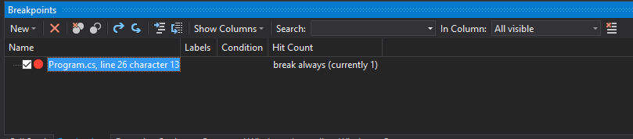

* A variable watch

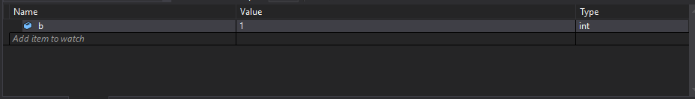

* The call stack

